**Earthquake Rescue Information System**

**A  Software Requirements Specification document submitted**

**By:**

**GROUP- 04**

|  |  |
| --- | --- |
| **NAME** | **ID** |
| Zaman Md Sumsush | 14-27822-3 |
| Farha Anika | 14-28003-3 |
| Jarin, Maliha Momin | 14-27826-3 |
| Haque, Sayed Tanzimul | 14-27318-2 |
| Bari, Fahadi | 14-26295-1 |

**Under the supervision of:**

**MOHAMMAD MAHMUDUL HASAN**

**Lecturer**

**Department of Computer Science**

**Faculty of Science & Information Technology**

**American International University – Bangladesh**

**Spring16_17**

**American International University-Bangladesh (AIUB)**

**18.08.2017**

|  |
| --- |
| **Table of Contents**  **1. Introduction**  **1.1 Problem Background**  **1.2 Solution for the problem**  **1.3 Why this solution is important**  **2. System Specification**  **2.1 User Stories**  **2.2 System Features**  **2.3 Non-Functional Requirement Specification**  **3. Design Specification**  **3.1 Use-Case Diagram**  **3.2 Class Diagram**  **3.3 Activity Diagram**  **3.4 ER Diagram & Data Dictionary**  **3.5 User Interface Design**  **4. Acknowledgement** |

**1. Introduction**

The purpose of this document describes the statement of work (SOW) for developing an automated system for earthquake rescue team to identify the possible position of victim human body from the wreckage of destroyed building. This particular documented (SOW) is intended for the further development of a fully functional earthquake rescue information system. This document also provides the vendors with the relevant t technical, performance, application, and architectural requirements of the system along with its deliverables. This also contains a brief analysis costing of the project, the possible risk that might the developers face

During the development period and its ultimate quality goals.

1.1 Problem Background

The number of earthquakes taking place have significantly increased in recent times. Many lives are lost due to the aftermath of this calamitous natural disaster. Most of the lives lost are due to getting trapped under the debris caused by destroyed buildings. A lot more lives are lost due to the lack of knowledge of where the victims might be within all the debris. Since rescuers usually do not know where victims are stuck they stay trapped and eventually die. This is a serious matter at hand as human lives are directly involved and through this project we can help bring improvements into the whole rescuing system and eventually may help save a few extra lives.

1.2 Solution for the problem

This software will help determine an estimated location of the trapped victims with the help of infrared scanners, 3d scanners and a database to store all the information collected from the sensors.

The 3-D scanner will take a 3D view of the entire building and store it in the database. There will be 5 Infrared scanners, 4 on each corner and 1 on the rooftop which will detect the position of anything that is emitting heat along with movement from within the building. Deriving from the shape of the thermal body and the fact that it is moving around we can determine if it’s coming from a human or not. The database will be updated in an interval of 10-15 minutes which would show us the positions of the thermal emitting bodies within the building after being merged with the 3D view of the building collected from the 3D scanners. If and when the building collapses due to an earthquake, the rescue team or the fire brigade can access the database from a central station (there will be one for each area) and collect the latest updated data of the particular building and can find out where the victims were last located within the building before the building had collapsed. Using these information an estimated location of the victims can be determined and the rescuers will set high priority on these locations.

1.3 Why this solution is important?

Firstly no such software has been developed previously for such purpose therefore making this particular project the first of its kind. As there are no such similar projects to compare to currently this project is acting as the basic and most feasible solution to this problem. However new and improved projects with higher feasibility and efficiency maybe developed in the future. Whatever the statistical data regarding this project it will be recorded as the most basic data and so the cost requirement for this particular software is considered to be minimum. Taking this into consideration the software has high feasibility to meet the business objective.

**2. System Specification**

**2.1 User Stories**

|  |  |
| --- | --- |
| Use-case | Corresponding user scenario |
| Registration | As a new user, to login into the software, i must first register with proper verification and once authorized I may log into the system. |
| Log in | As an already existing user, after registering with proper information and verification i can log in to gain access to a few features. |
| Access 3D view | As a user, i can check the 3D view of my homes collected from the 3D scanners, but only in case of emergencies. (I cannot make any changes to the view, admin privilege only) |
| Access Infrared View | As a user, I can also access the Infra-red view and check where everyone within the building is present via thermal detection only in case of emergency. |
| Sound Alarm (Emergency only) | As a user I can logout of my account only in case of major emergencies, otherwise logging out is strictly forbidden because logging out could mean that something has gone wrong in my residence, which will sound an alarm to the admins. |
| Access Database | As a user, I cannot access the database except only in case of emergency in which case I can access the information with in the database related to me or my family.  As an admin, I can access and edit the database but only when permission is granted by the government. |
| All | As an admin i will have a unique identifier assigned to me by the government. I can access and edit any feature within the software e.g: edit 3D view, edit Infrared view, add/delete user and user registration verification. However I need to be granted these permission by the government itself. |

**2.2 System Features**

**2.2.1 System Feature 1: Registration**

FR1: User has to input the information asked within a field box and the given informations will be cross checked from the database with already existing users in case of critical information (e.g.: username, password, cell-phone number).

FR2: Once cross checking is complete system will check if the minimum requirements of the given information are met. If yes, a user profile will be created, if no, user will be asked to input information once again only this time user will be asked to maintain the minimum amount of information asked to be given.

FR3: Once all the requirements are met, system will add user to the database and a new profile with all the given information will be added too.

**2.2.2 System Feature 2: Log-in**

FR1: User will be asked to input Username or Email Address and password to log in.

FR2: System will cross check the input username and password with database for validation.

FR3: If validation is successful system will grant access to user.

FR4: If validation is unsuccessful system will ask user to re-enter username and password and user will be given 3 chances.

FR5: If validation is still unsuccessful a password will be sent to the given email address to ensure security and user will be able to use that password to get access.

**2.2.3 System Feature 3: Access Profile**

FR1: User will have the option to access his profile which will provide all the information he/she has inputted during registration.

FR2: User can update/edit any information in which case database will be updated but only after validation is done post editing.

**2.2.4 System Feature 4: Access 3D-View**

FR1: User will be able to access the latest updated (interval of every 15 minutes) 3D-View of his residence but only in case of emergencies in which case admin permission will be required.

FR2: Only admin is allowed to alter the view or make any changes.

**2.2.5 System Feature 5: Access Infrared View**

FR1: User will be able to access the latest updated (interval of every 15 minutes) infra-red view of his residence but only in case of emergencies in which case admin permission will be required.

FR2: Only admin is allowed to alter the view or make any changes.

**2.2.5 System Feature 6: Access and update Database**

FR1: Only the admin (assigned by the government) is allowed to access and update the database when and if required at all.

FR2: System will ask for admin’s Unique Identifier if admin wants to access or update database.

FR3: Database can only be accessed from the computer based in the central station ( 1 central station will be assigned to each area).

**2.3 Non-Functional Requirements**

**2.3.1 Performance:**

Software and hardware performance is high as expensive hardware will be installed in order to avoid any errors in precision. Large servers with strong computing power will be used as there will be quite a number of information stored and updated every 15 minutes at the least. Backup servers will be maintained if anything were to happen to main server. High-end technology will be used as it is a matter of life and death.

**2.3.2 Robustness:**

The entire system will be backed up by external power and generator. Internally system will have a secondary server and also a auto crashing system in case of security breach with a backup elsewhere. If the system is ever to fail while giving a service, troubleshooting options will be present to check for problems and fix them.

**2.3.3 Usability:**

The system will be easy to operate and maneuver both for admins and users as majority users may not be highly technical with such systems and therefore to avoid any complicacies user interface will be kept as simple as possible while ensuring that security is not compromised.

**2.3.4 Security:**

The security of the system is given the highest priority among all the non-functional requirements. As the system will include personal information of civilians and a 3D view of their residence along with thermal detection view, privacy will be maintained with maximum priority. Any and all privileges will only be granted by officials representing the government of the country only if the government feels the situation is in a state of emergency.

**3. Design Specification**

**3.1 Usecase**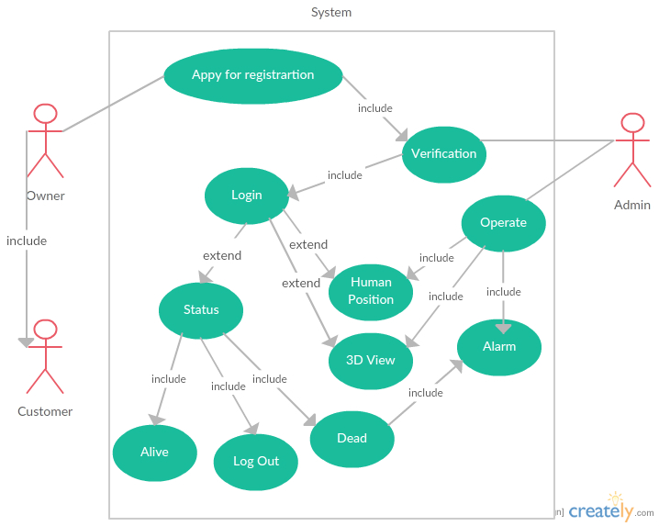

**3.2 Class Diagram**

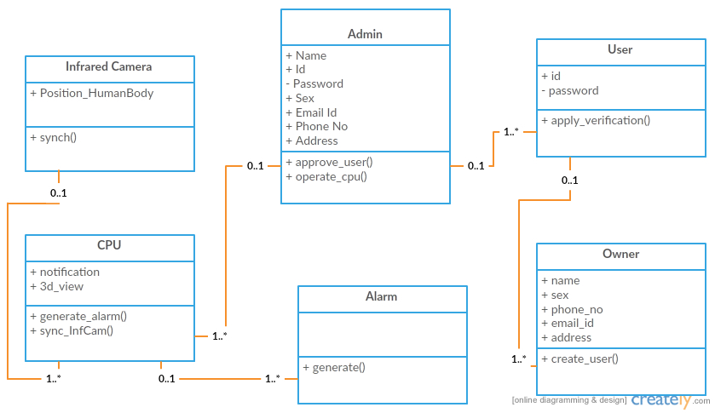

**3.3 Activity Diagram**

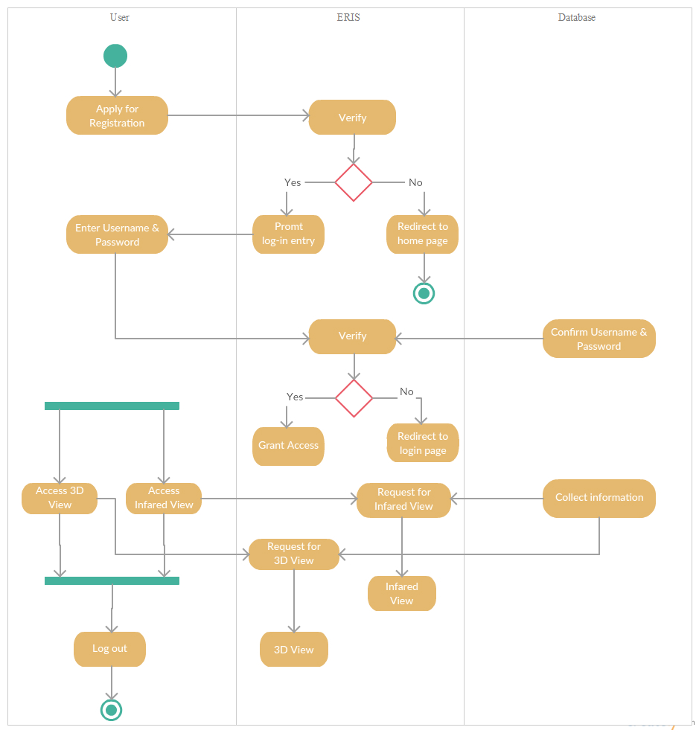

**3.5 Entity Relationship Diagram**

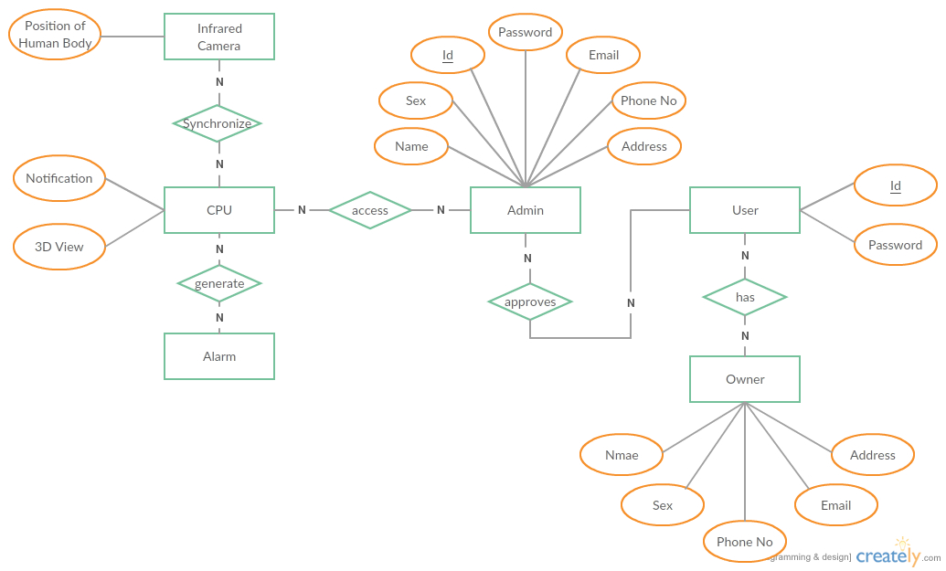

**Data Dictionary**

|  |  |  |  |  |  |  |  |  |
| --- | --- | --- | --- | --- | --- | --- | --- | --- |
| **Unique Identifier (admins only)** | **Name** | **Sex** | **Address** | **Contact No** | **\*Username** | **\*Password** | **Email** | **Security Question** |
| Admin_769213 | Alex | Male | Banani | 017xxxxxxxxx | Alex_user1 | Alexuser1 | Alex_hunter@hotmail.com | What is your mother’s maiden name? |
| - | Seth | Male | Mirpur | 018xxxxxxxx | Seth_user2 | Sethuser2 | Seth_green@gmail.com | What is your first pet’s name? |

**3.6 User Interface Design**

**3.6.1 Log-In Page**

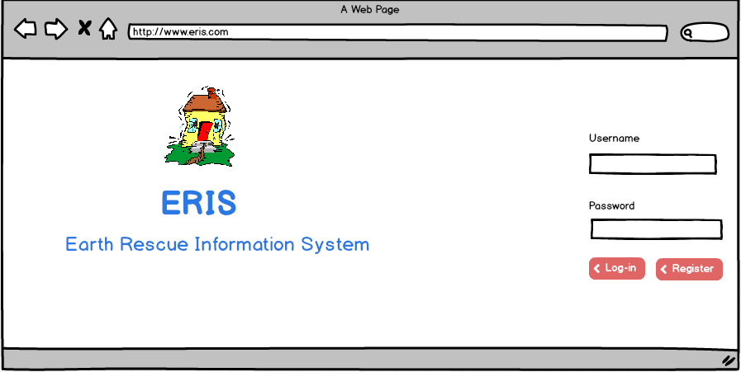

**3.6.2 Registration**

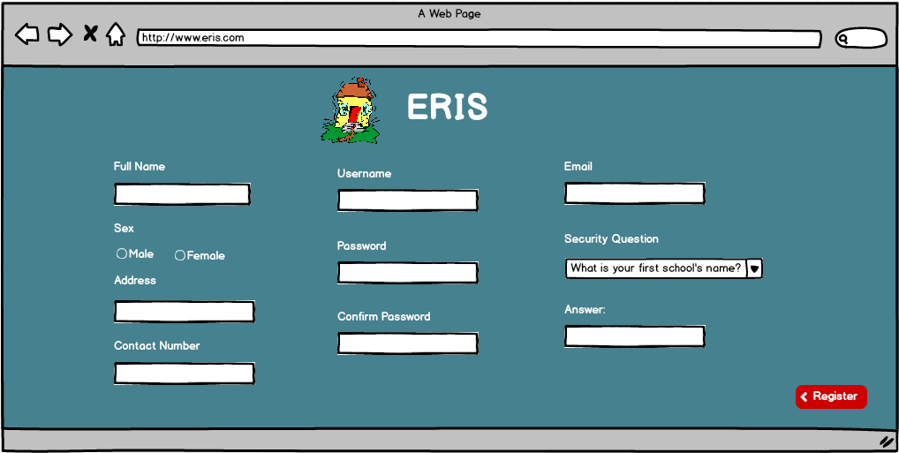

**3.6.2 Profile**

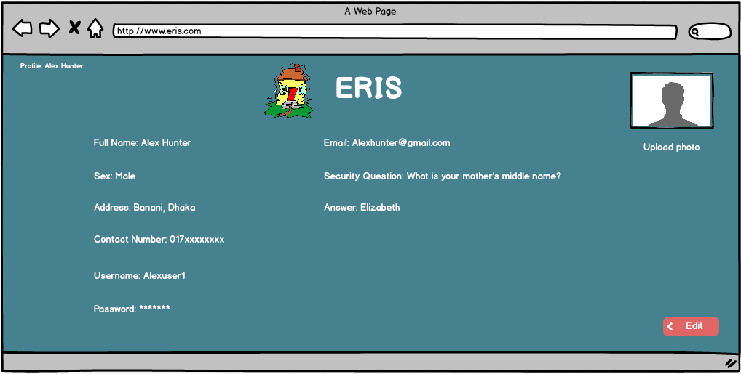

**3.6.3 Home Page**

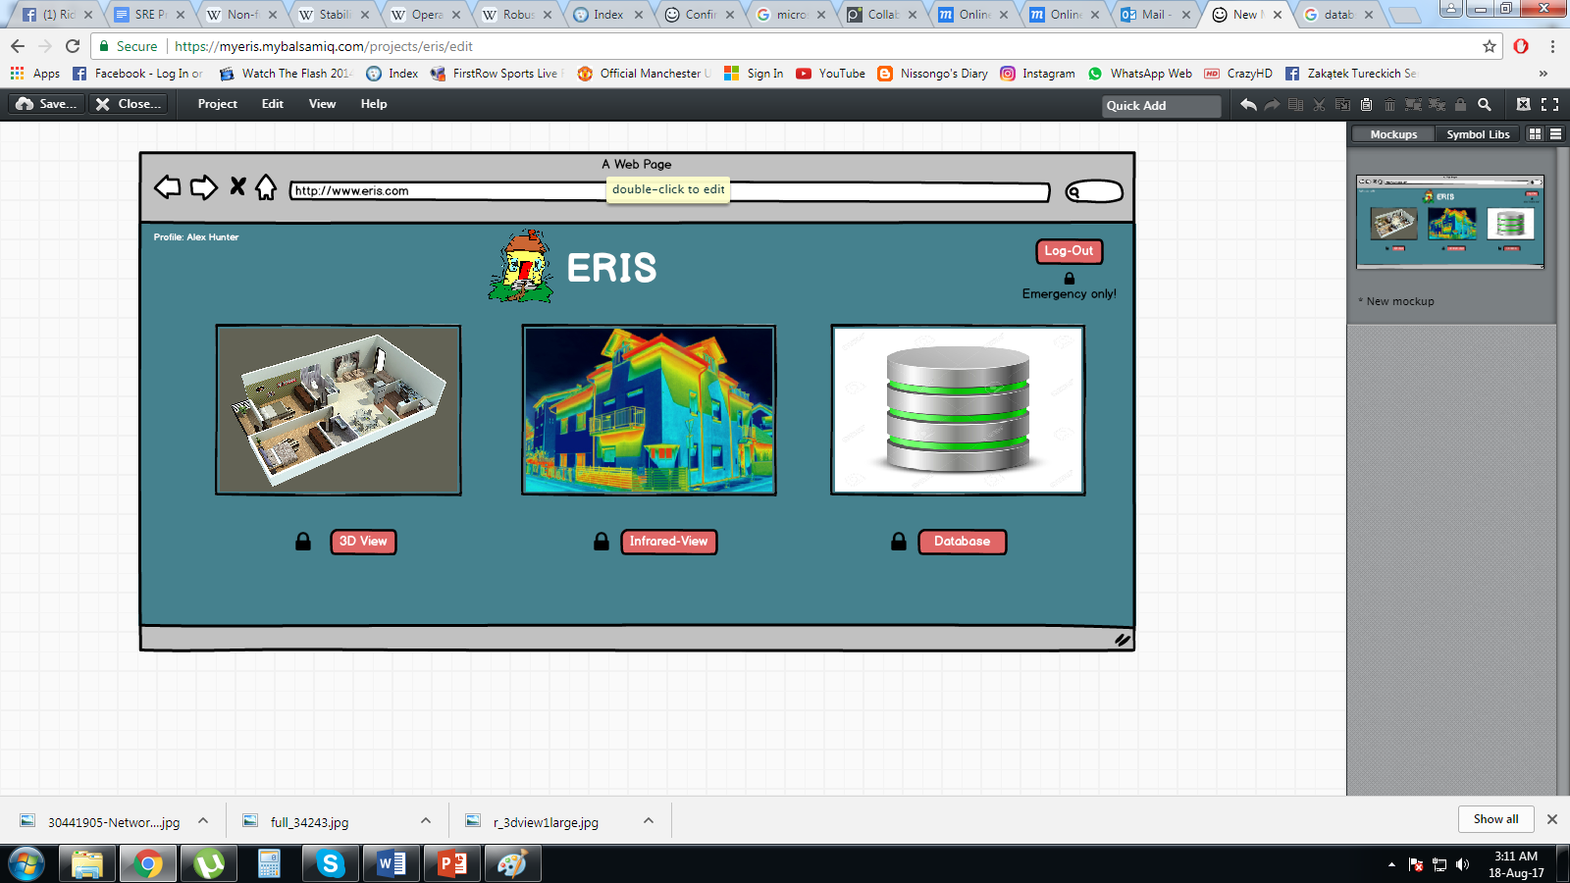

**4. ACKNOWLEDGEMENT**

At the end of the project, we would like to take the opportunity to sincerely give thanks to our respected faculty MD. Mahmudul Hasan sir. Also would like to acknowledge the hard work put on by every team member in order to successfully complete the document.